**LIBRARY MANAGEMENT SYSTEM**

**BY**

**VAMSEEKRISHNA KATTIKA**

**USER GUIDE**

This document let the librarians know how to use the library management system.

The Home Page is as follows. It provides links to all other pages of the system.

The pages are

1. Search

2. Check out books

3. Check in books

4. Borrower Management

5.Manage Fines

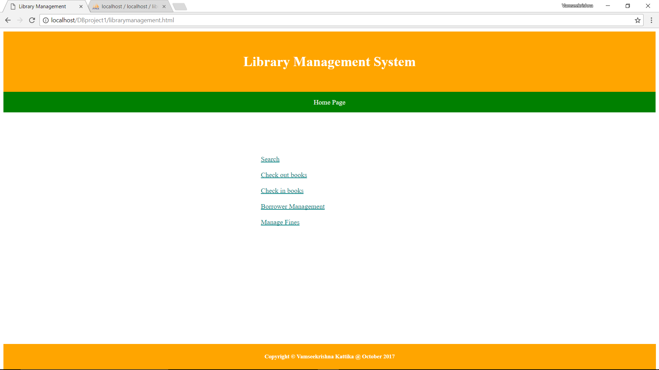

1. **Search Page**: In the search box provided, enter your search string i.e., any of ISBN, title, and / or Author and click on ‘Search’. It will show the ISBN, Title, Author(s), and availability of the book.

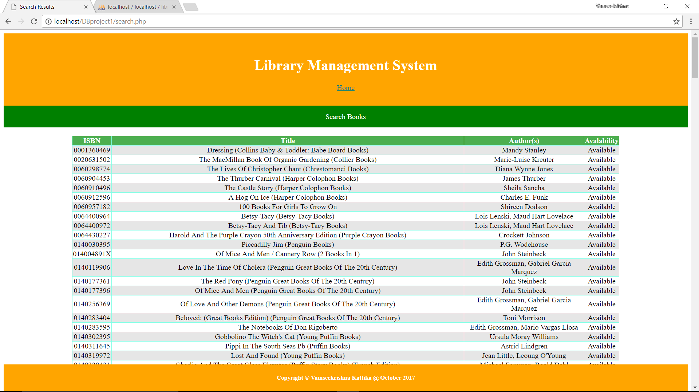

If nothing is provided and ‘Search’ is clicked, it will show the error “**Please enter ISBN or title or author name of the book**”.

2. **Check out books**:

In the search field provided, enter any of ISBN, title, and / or Author and click on Search. It will show the ISBN, Title, Author(s). If nothing is provided and ‘Search’ is clicked, it will show the error “**Please enter ISBN or title or author name of the book**”

Click on the ‘Radio’ button to check out a book. When the radio button is clicked, it will redirect to another page and it will ask for Card No. Enter the card no and click on ‘Submit’ button.

If the checkout is successful, it will show success message. If the book is already checked out, it will display appropriate message. If the borrower exceeds the maximum limit of 3 books, it will show appropriate message.

If the borrower is not present in the system, it will show an error “Borrower doesn't exist. Please Sign Up”.

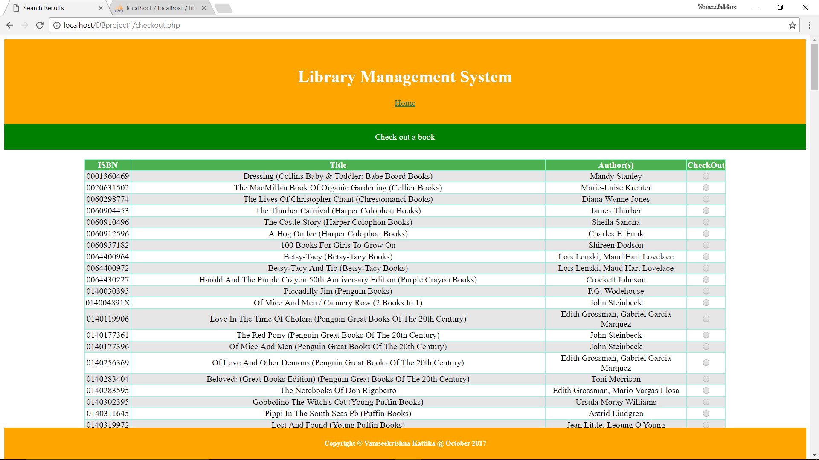

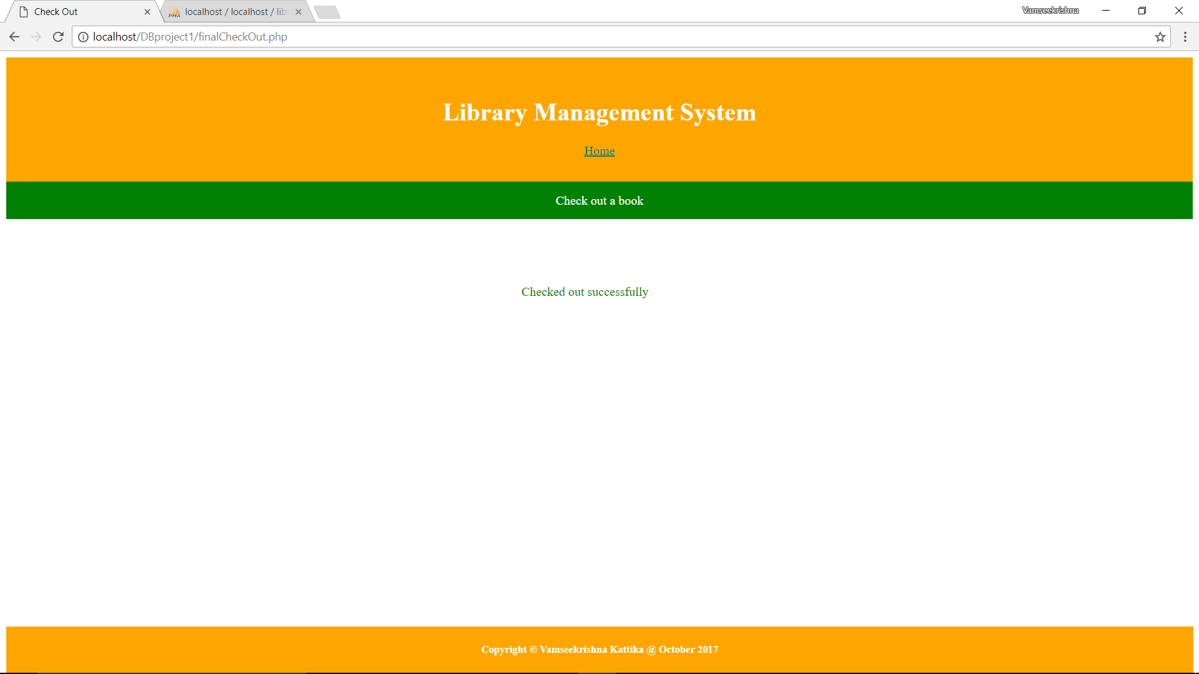

3. **Check in books:** Here enter ISBN number or Borrower name or Card No and click on ‘Search’. If any books are needed to be checked in, it will show the details. Otherwise, it will show “Now results found”.

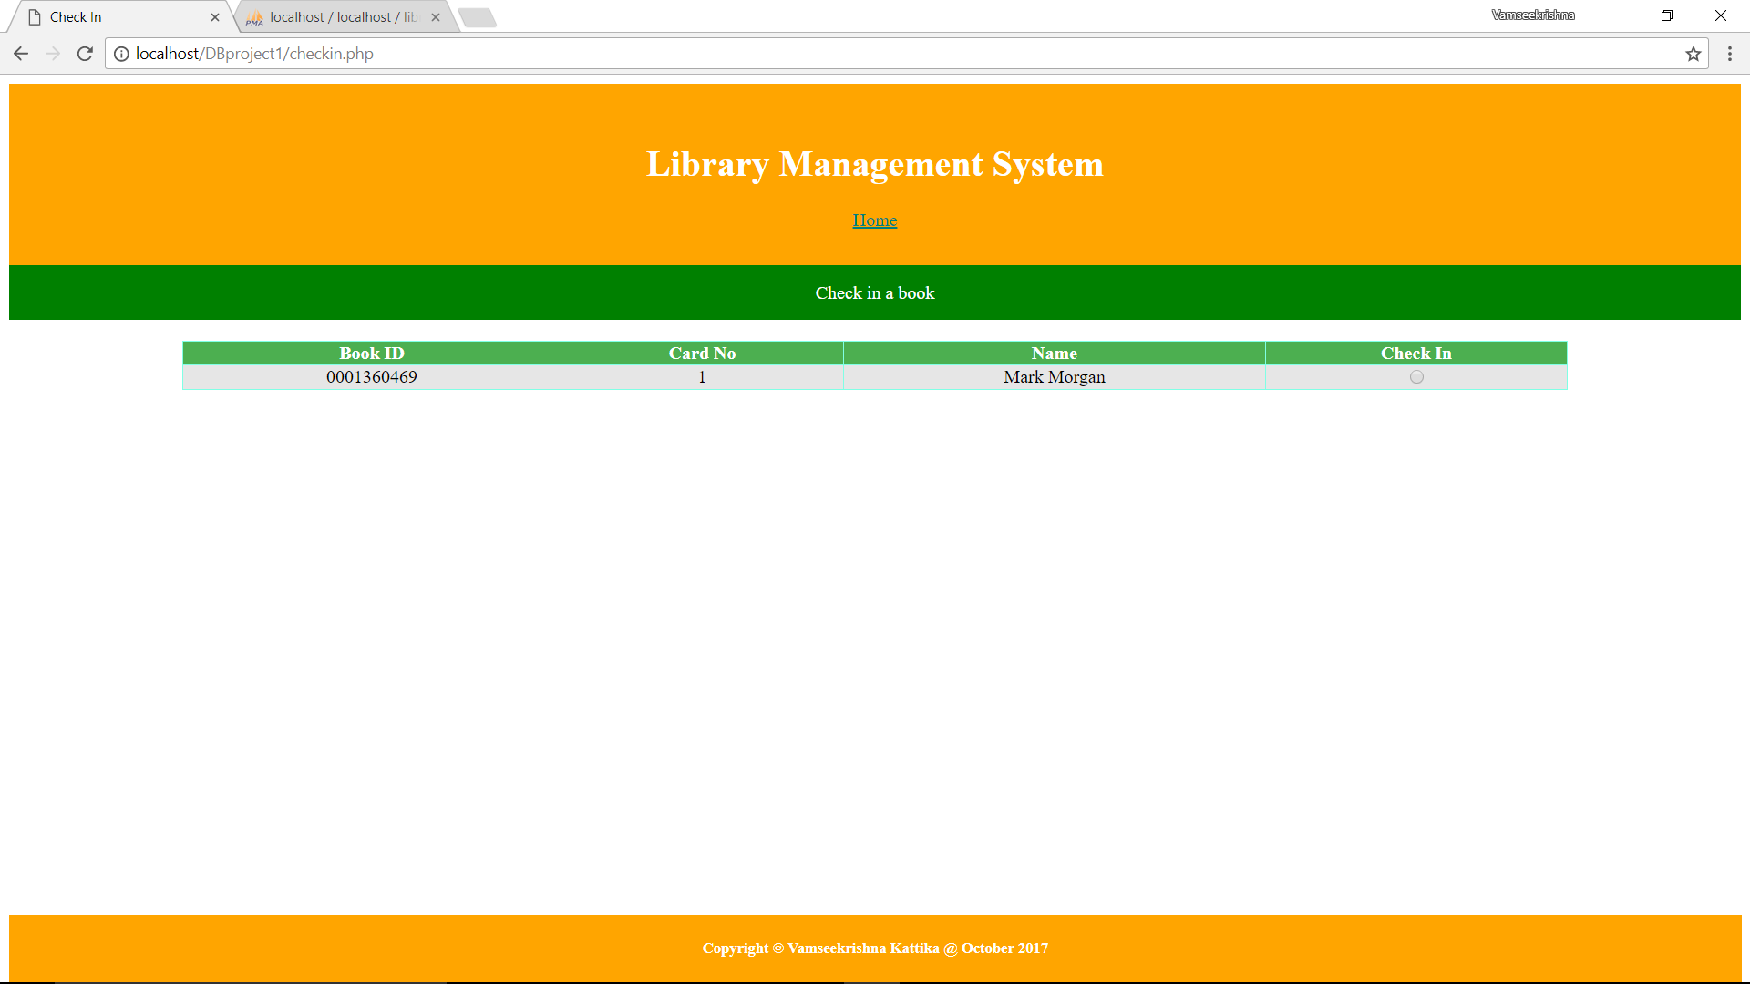

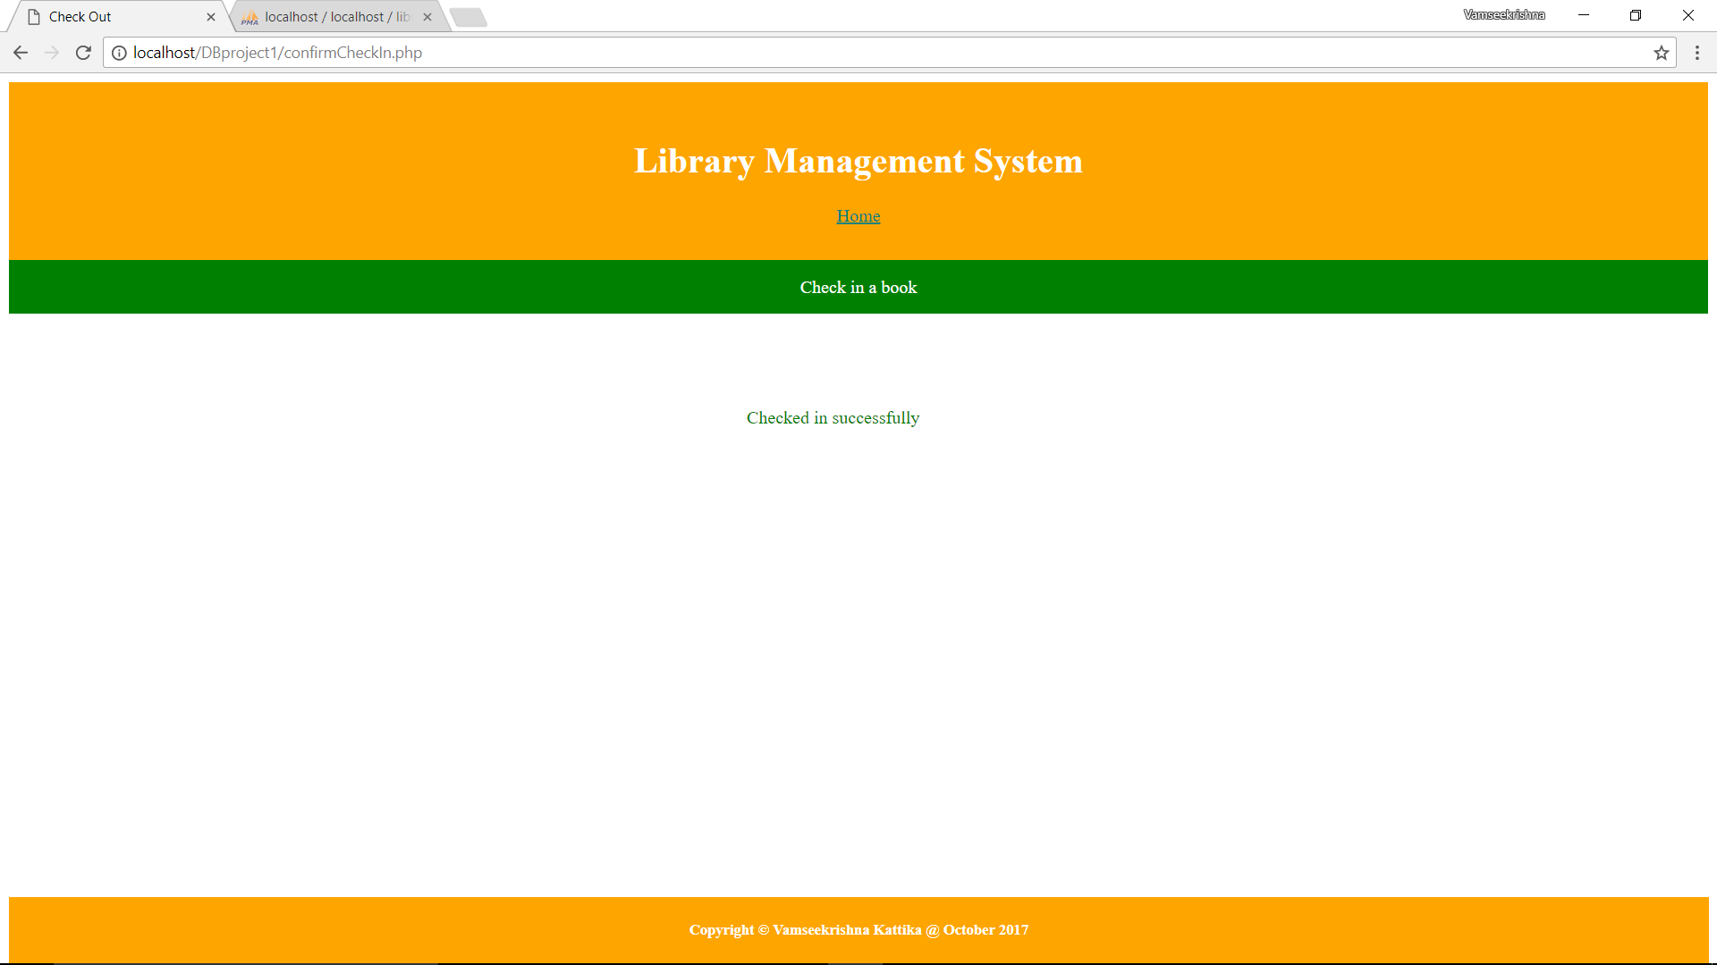

When the results are provided, click on the corresponding radio button to check in the book. The book will be automatically checked in.

**4. Borrower Management:**

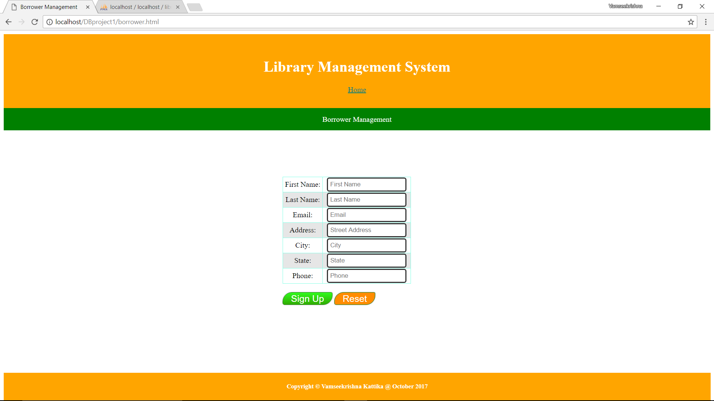

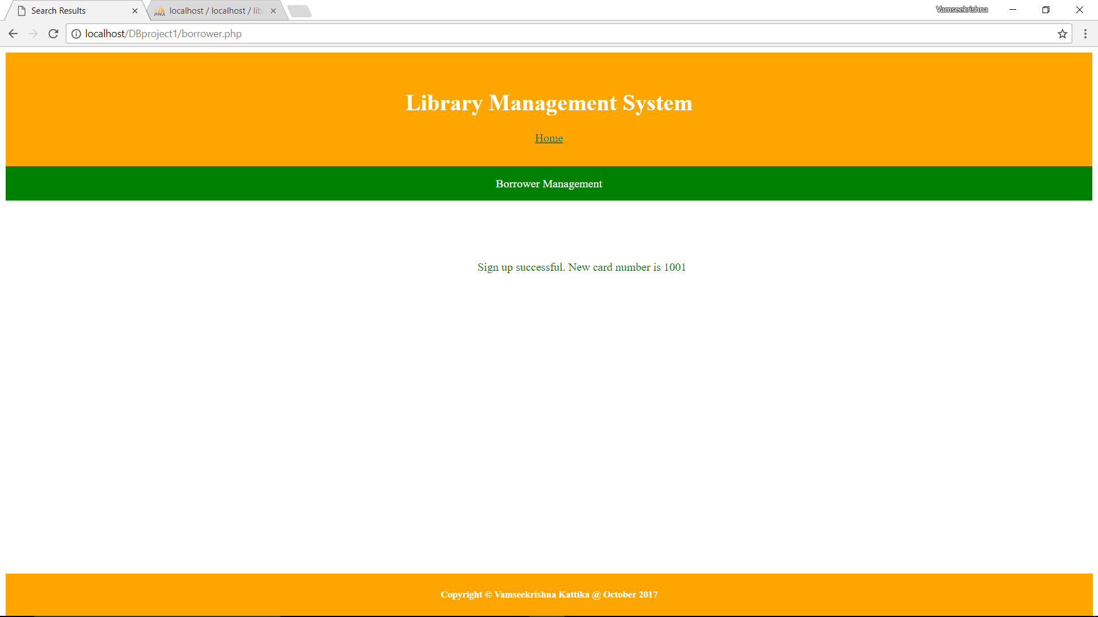

In the page, please provided all the fields. All the fields are mandatory. When all the fields are filled, click on Sign Up button to sign up. If email and phone are unique, the system will allow to sign up and will show the new Card Number assigned to the new user. Otherwise it will show an error “Email or phone already exits with card number 1001”.

Note: Here 1001 is the card number, which has the details entered by the already existing borrower.

**5. Manage Fines:** In this page there are two separate links for two other pages, Update Fines

And Payments.

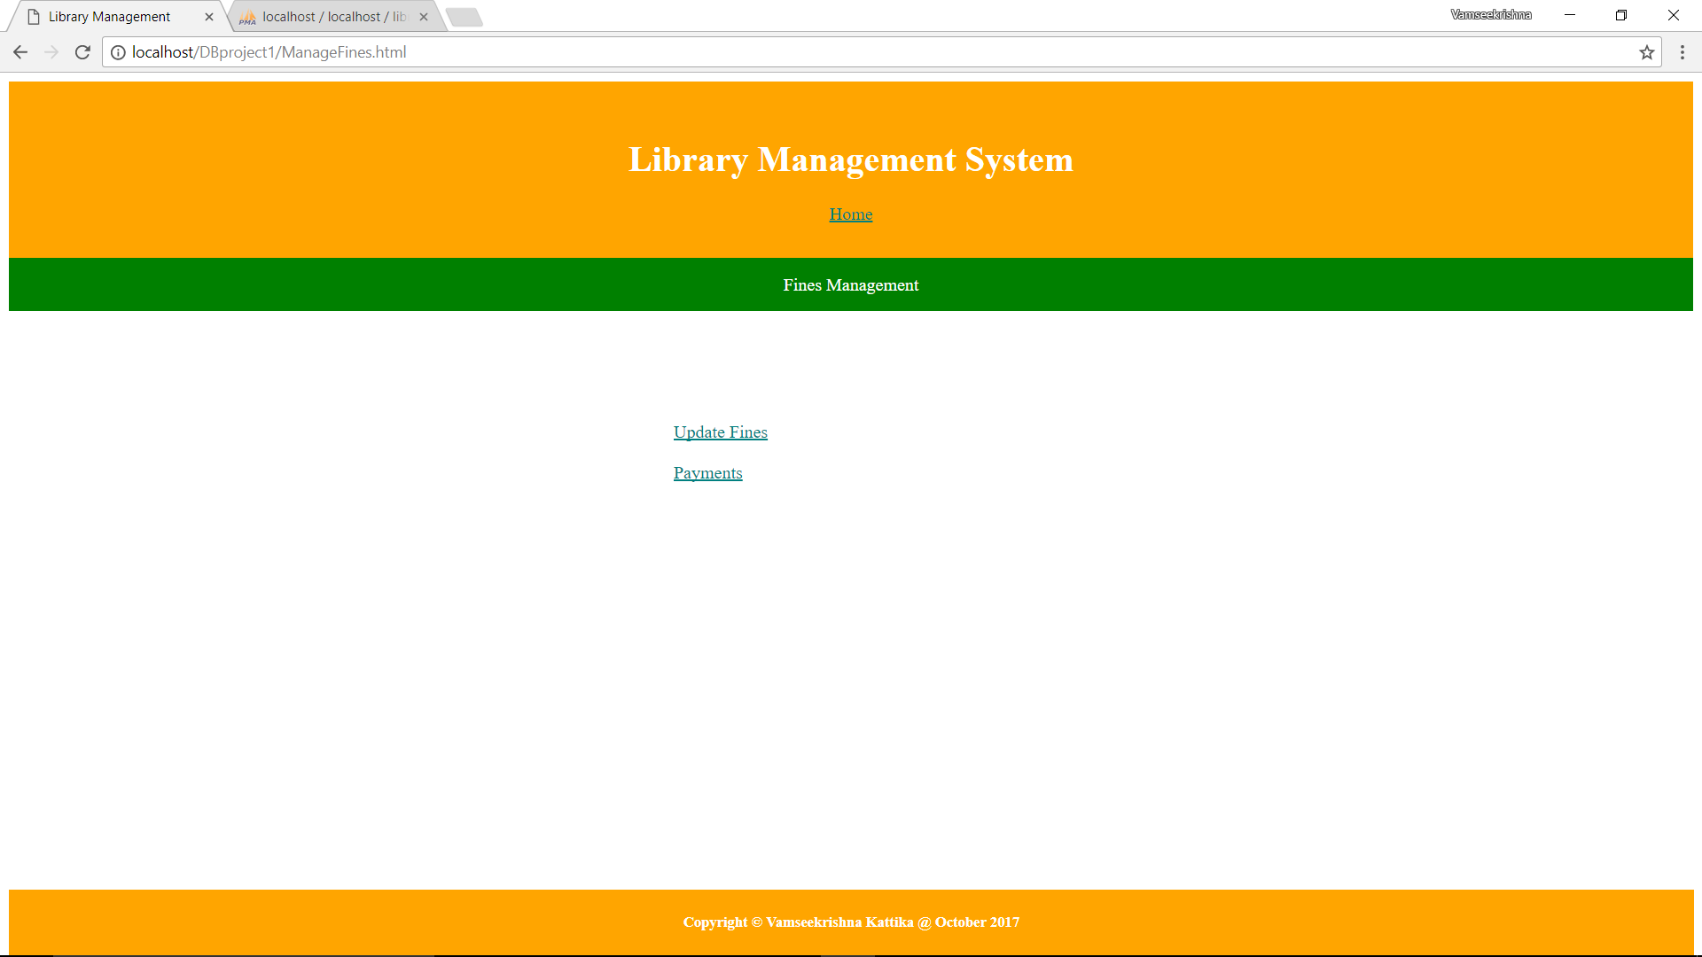

When click on Update Fines, it will be redirected to another page. There “Update Fines” button is provided. When clicked on that button, the fines table will be updated.

When clicked on Payments link, it will redirect to another page. It will have two buttons, “Show Paid Fines” and “Pay Current Fines”.

When clicked on Show Paid Fines button, it will show all the payments done by the borrowers previously. If there is nothing to display, it displays “No results found”.

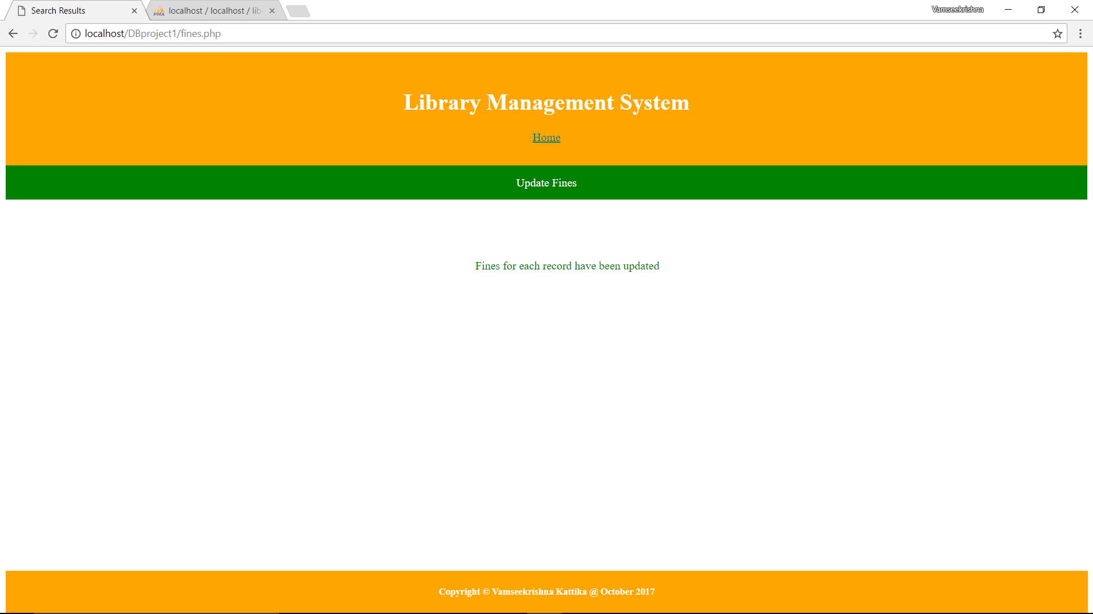

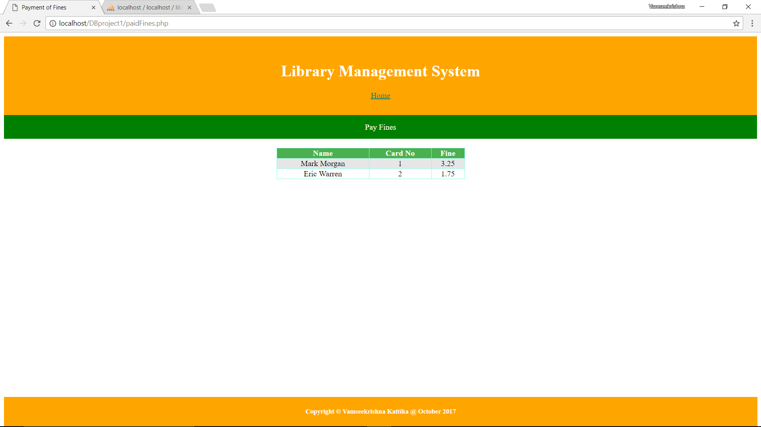

When clicked on Pay Current Fines button, it will show all the payments due by the borrowers. It also prompts for a Card No. Enter the Card No for which the payment needs to be done and click on proceed. It will show the message “Payment Successful”.

If there is nothing to display, it displays “No results found”.

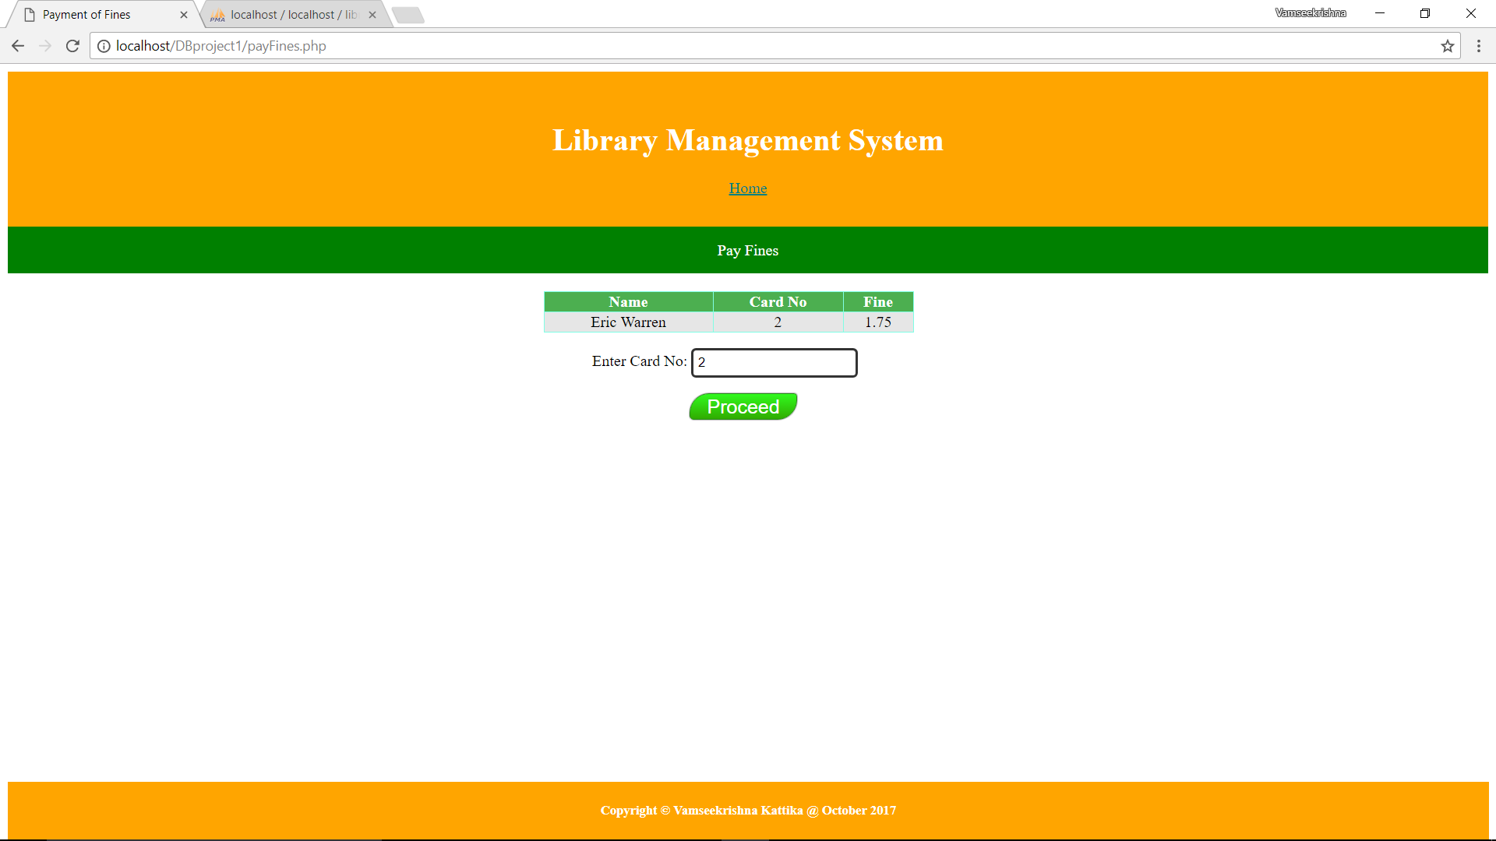

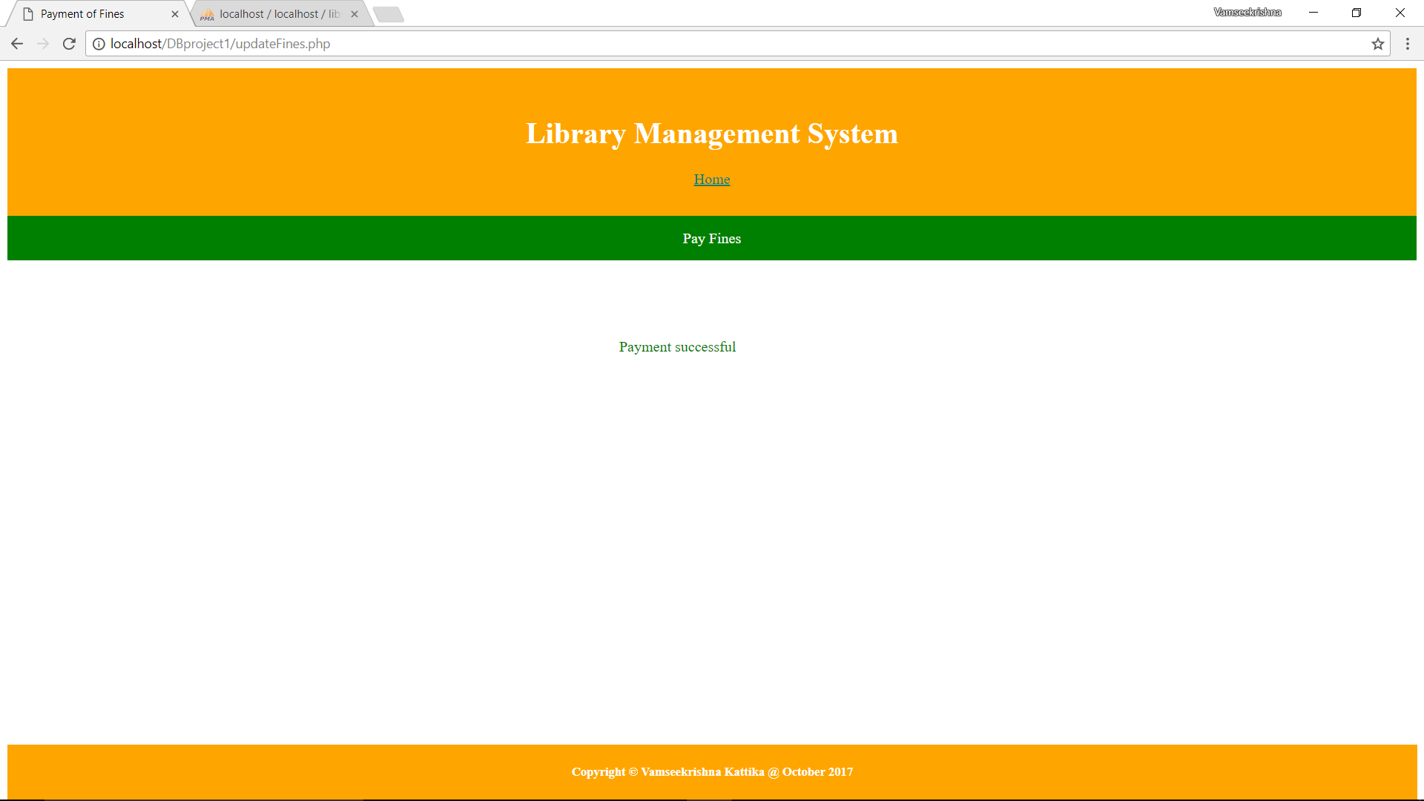

Note: The system will update the fines record for those books which are returned. For those books, which are still out it won’t charge the fine as the book is not returned.